ABSTRACT
The retail industry operates in a dynamic environment where daily sales are influenced by complex factors ranging from consumer behavior to seasonal trends. Accurate sales forecasting is a critical component of effective supply chain management, inventory optimization, and financial planning. Overestimating demand leads to surplus inventory and holding costs, while underestimating results in stockouts and lost revenue.
Traditional forecasting methods often rely on simple moving averages or intuition, which fail to capture the stochastic nature of daily sales data. The Autoregressive Integrated Moving Average (ARIMA) model provides a robust statistical framework for modeling time series data by capturing linear trends and autocorrelations.

INTRODUCTION
To analyze the statistical properties of the daily sales data, including stationarity, trend, and seasonality.
To transform the time series data into a stationary series using differencing or transformation techniques (e.g., Log-transform).
To identify the optimal ARIMA parameters based on Autocorrelation (ACF) and Partial Autocorrelation (PACF) functions and Information Criteria (AIC/BIC).
To evaluate the model's accuracy using Mean Absolute Error (MAE) and Root Mean Squared Error (RMSE).To generate a 30-day forecast of daily sales revenue to assist in inventory planning.

OBJECTIVES:
(1) To analyze student interaction patterns using metrics such as session count, average session duration, and weekly AI tool usage. (2) To evaluate the relationship between AI tool engagement and academic performance through improvement scores, tasks completed, and adaptive difficulty levels. (3) To assess user satisfaction and perception of AI tools by examining perceived usefulness, ease of use, trust, and satisfaction scores. (4) To incorporate sentiment and emotion analysis of text feedback using polarity, subjectivity, sentiment labels, and primary emotion categories. (5) To provide data-driven insights to guide the optimization of AI-assisted learning systems for improved educational outcomes.

DATA
The dataset used in this analysis was generated to simulate daily operational metrics for a mid-sized retail business. To ensure consistency, the variables were patterned after typical indicators commonly reported in real-world business analytics: daily sales revenue, marketing expenditures, website traffic, average temperature, inventory levels and day-of-week characteristics.

METHODOLOGY
The analysis follows a structured approach similar to traditional OLS-based research designs, adapted for multiple linear regression using Python libraries such as pandas, scikit-learn, seaborn, and matplotlib.
(1) Data Collection and Preparation: The dataset contains variables related to AI tool usage, student
attitudes, ethical concerns, and academic performance, including pre-test and post-test scores. Data preparation involved selecting relevant numerical predictors, and preparing the dataset for regression modeling using pandas. Exploratory data analysis (EDA) was conducted through seaborn and matplotlib to visualize distributions, correlations, and improvement patterns.
(2) Model Specification and Representation: A multiple linear regression model was selected to examine how AI-related factors, usage frequency, perceived usefulness, trust, and ethical concerns influence post-test scores. The model specifies post-test score as the dependent variable, with predictors representing behavioral, perceptual, and contextual measures of AI tool adoption.
(3) Coefficient Estimation Using Linear Regression: The model was trained using scikit-learn’s LinearRegression. A Lasso regression model was additionally applied to identify the most influential features through regularization and feature selection.
(4) Prediction of Values: The dataset was divided into training and testing subsets. Predictions on the test set were generated to assess how well the model generalizes to unseen data. Metrics such as R² were computed to evaluate predictive accuracy.
(5) Interpretation and Visualization of Results: Scatter plots and comparison graphs were produced using seaborn, ggplot2 and matplotlib to visualize predicted versus actual post-test scores, as well as improvements from pre-test to post-test. The regression coefficients were analyzed to identify which AI-related factors significantly contribute to student performance. Lasso-selected features further clarified the variables with the strongest explanatory power.
Findings
figure 1: grade levels
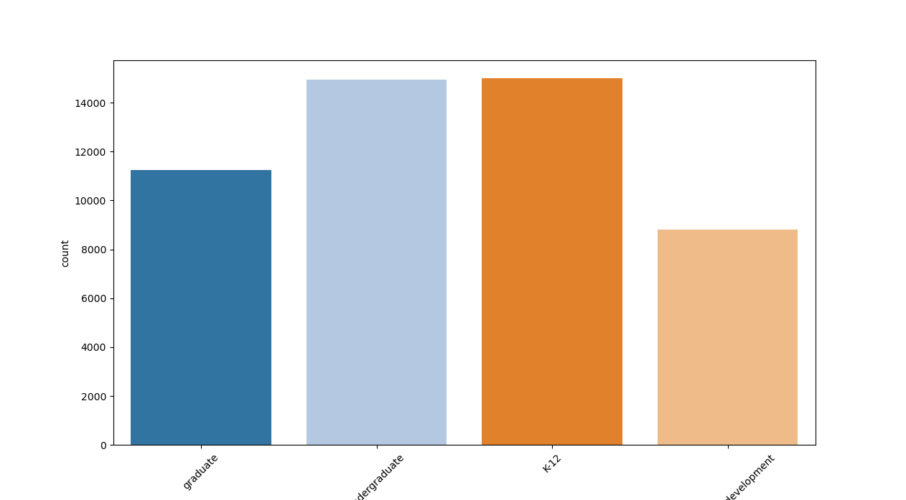
This bar graph shows that there’s more Ai users on K-12(Orange) and undergraduate(light blue) level. This suggests that AI tools are more commonly adopted among students in K-12 and undergraduate levels, possibly due to easier access, greater integration in learning activities, or higher curiosity and willingness to try new technology at these stages.
Figure 2: T test result

T-test result shows that Ai Usage among students mostly have a positive impact on their final scores. With the mean difference of 7.722 and p value of almost 0.
Source
Case Study Source Codes.
https://github.com/AlieeLinux/case-study2

